Lecture 1
BASIC ENZYMOLOGY
INTRODUCTORY ENZYMOLOGY
Enzymes are important proteins that serve as biological catalysts for reactions in all living organisms. Like all catalysts, enzymes increase the rate of reactions, but they themselves are not permanently changed in the process. Enzymes are essential to the biological reactions that occur in the body, which would otherwise often proceed too slowly to be of any use. In humans, enzymes must catalyze reactions under very specific physiological conditions, usually a pH around 7.4 and a temperature of 37 °C.

Enzymes as Biocatalyst
Although the phenomena of fermentation and digestion had long been known, the first clear recognition of an enzyme was made by Payen and Persoz when they found that an alcohol precipitate of malt extract contained a thermolabile substance that converted starch to sugar. This substance, now known as Amylase was at the time named diastase. The first enzyme to be obtained in pure form was urea, crystallised from Jack Beans in 1926. The work was carried out by James Sumner, for which he was awarded the 1946 Nobel Prize. Since them, thousands of different enzymes have been purified and their structures worked out.
With the exception of a few catalytic RNA molecules (ribozymes), all enzymes are proteins. They range in size from large multiple subunit complexes (called multimeric enzymes) to small single subunit forms.
The region within the enzyme molecule that contains the chemical/functional groups to which the reactants (substrate) binds is called the active site/catalytic site/substrate binding site of the enzyme. The particular arrangement of an enzyme’s amino acid side chains in the active site determines the type of molecules that can bind and react there.
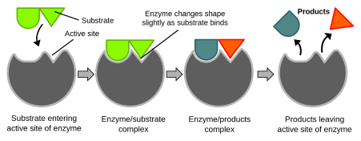
Figure 1: Active Site of an Enzyme.
The active site of an enzyme is usually found in a cleft or pocket that is lined by amino acid residues that participate in recognition of the substrate.

Cofactors
Many enzymes have small non protein molecules associated with or near the active site that determine substrate specificity. These are called cofactors. A cofactor may be

i. A coenzyme- A non-protein organic substance which is loosely attached to the protein part. Coenzymes are often derivatives of vitamins. They may or may not be modified in the reactions.
Those that are altered are also called co-substrates. The B vitamins supply important components of numerous coenzymes.
ii. A prosthetic group- An organic substance which is tightly bound either covalently or non-covalently to the protein portion e.g. flavin coenzymes, pyridoxal phosphate, biotin.
iii. A metal ion activator. These include most divalent metal ions as well as other ions e.g. Cu²⁺, Zn²⁺, Mg²⁺, Ca²⁺, Co²⁺, Fe²⁺, Fe³⁺ and Mo³⁺. Enzymes which require a metal ion for activity are called metal-activated enzymes. Metal ions are sometimes tightly bound to the protein portion. Enzymes containing such are called metalloenzymes.
The protein portion is called the apoenzyme while the entire active complex is called the holoenzyme i.e. Apoenzyme + Cofactor = Holoenzyme.

Apoenzyme + Cofactor Holoenzyme
(protein only) (active)
(inactive)
The major function of the coenzyme is that it prepares the active site of the enzyme for catalytic activity.
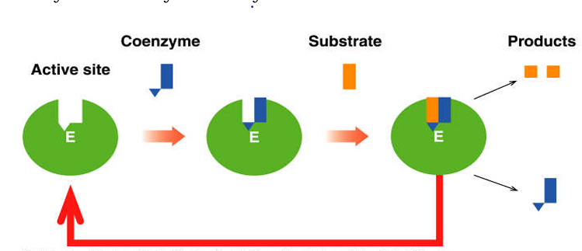
Figure 2: Illustration of the function of coenzyme.
Table 1: Examples of Coenzymes, Metal ion Activators and Non-vitamin Coenzymes.
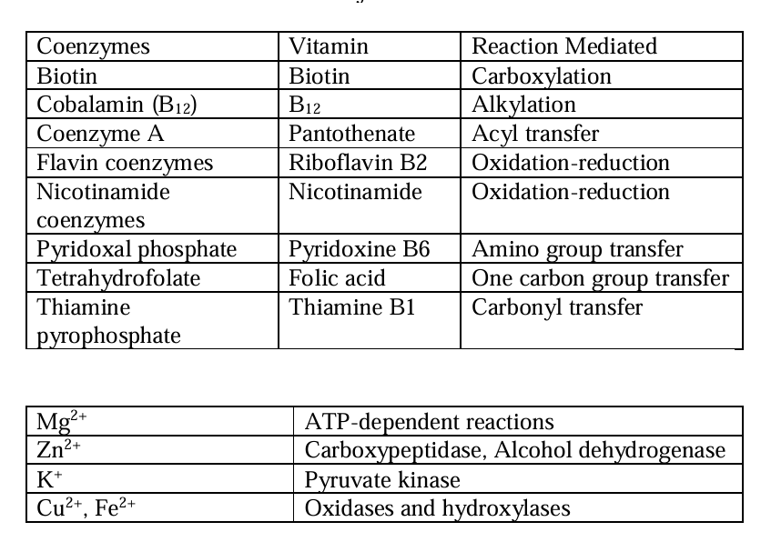

Non-Vitamin Coenzymes
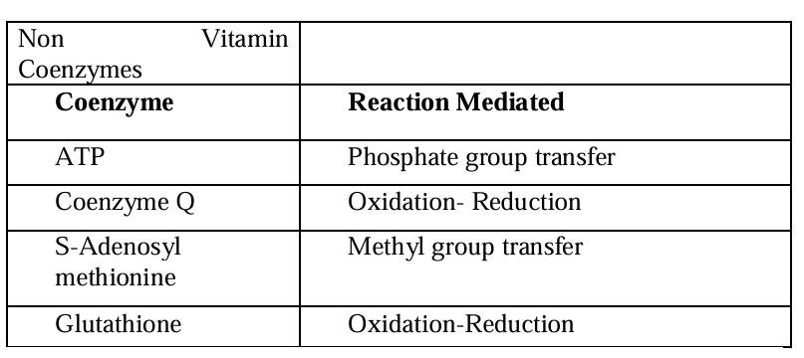

Naming and Classification of Enzymes
Except for some of the earliest studied enzymes e.g. pepsin, rennin and trypsin, most other enzymes are known by common names obtained by adding the suffix-ase to the name of the substrate or to the reaction that they catalyze e.g. glucose oxidase, transaminases etc. A systematic scheme for naming/ classifying enzymes was adopted in 1972 by IUB.
In this system, each enzyme has a unique name and code number that reflects the type of reaction catalyzed and the substrates involved. The code number is made of 4 figures which indicate the main class, sub class, sub sub class and the serial number of the enzyme in its sub sub class e.g. the enzyme commonly called hexokinase has the IUB designation ATP: D- hexose-6 phosphotransferase EC 2.7.1.1. This identifies the enzyme as a member of class 2 (tranferases), sub class 7(involves transfer of a phosphoryl group), Sub-sub class 1 (an alcohol is the phosphoryl acceptor). The last digit indicates that the enzyme is the first in its sub sub class.
For Example, the enzyme HEXOKINASE is named as follows: IUB Name: ATP: D-Hexose-6 phosphotransferase EC 2.7.1.1.
This identifies the enzyme as follows:
i. a member of class 2 (transferase),
ii. sub-class 7 (Reaction involves transfer of a phosphoryl group
iii. Sub sub class 1 (an alcohol is the phosphoryl acceptor)
iv. Serial No 1 (in its sub sub class)

